**PYTHON PROGRAMMING**

**ASSESSMENT – 2**

**Lab Challenging Exercise – 2**

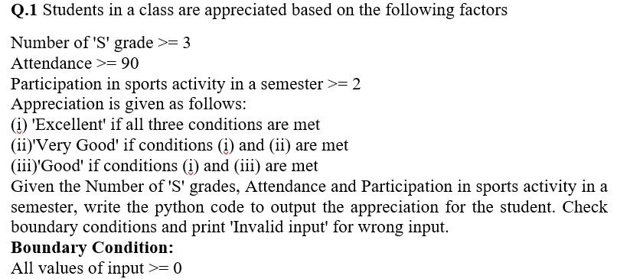

**CODE:**

sGrades = int( input( "\n Enter the number of 'S'

grades: " ) )

attendance = int( input( "\n Enter the attendance (%): " ) )

sportsParticipation = int( input( "\n Enter the sports Participation value: " ) )

if(sGrades >= 0 and sGrades <= 8 and attendance >= 0 and attendance <= 100 and sportsParticipation >= 0 and sportsParticipation <= 10):

    if( sGrades >= 3 and attendance >= 90 and sportsParticipation >= 2 ):

        print("\n Excellent\n")

    elif( sGrades >= 3 and attendance >= 90 ):

        print("\n Very Good\n")

    elif( sGrades >= 3 and sportsParticipation >= 2 ):

        print("\n Good\n")

else:

    print("\nInvalid Input\n")

**SCREENSHOT OF OUTPUT:**

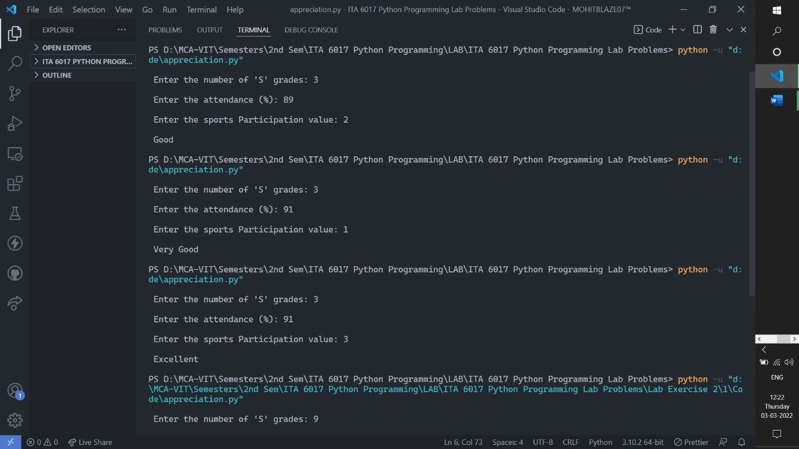

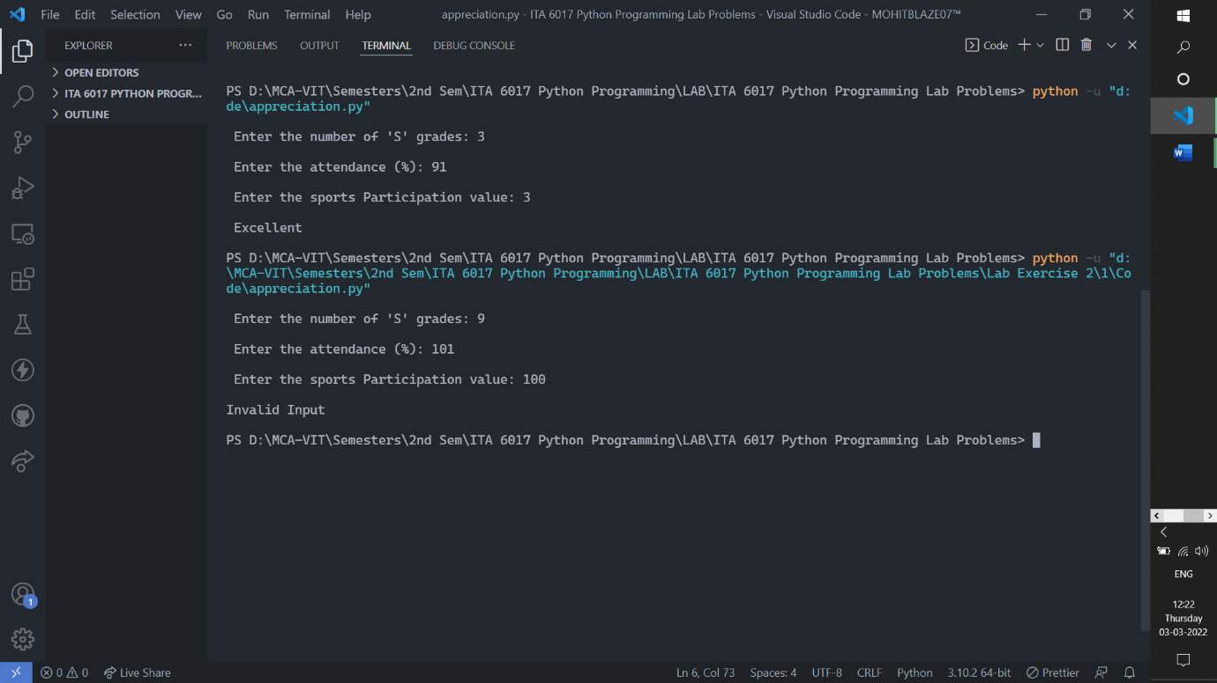

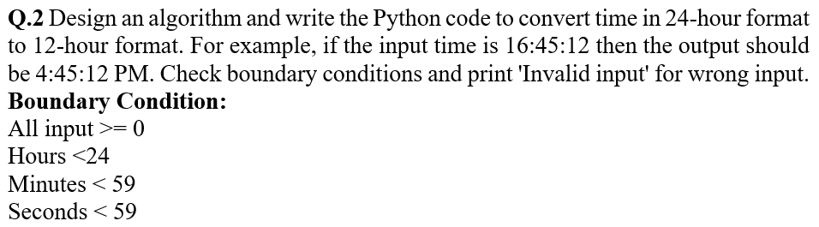

**CODE:**

hours = int( input( "\n Enter the hours in 24 hours

format( 1 - 24 ) : " ) )

minutes = int( input( "\n Enter the minutes ( 1 - 59 ): " ) )

seconds = int( input( "\n Enter the seconds ( 1 - 59 ): " ) )

if( hours >= 24 or minutes > 59 or seconds > 59 ):

    print("\n Invalid Input\n")

else:

    if hours <= 12:

        convertedHoursValue = hours

    else:

        convertedHoursValue = hours - 12

    print("\n 24 hours format time ->",hours,":",minutes,":",seconds)

    print("\n 12 hours format time ->",convertedHoursValue,":",minutes,":",seconds,"\n")

**SCREENSHOT OF OUTPUT:**

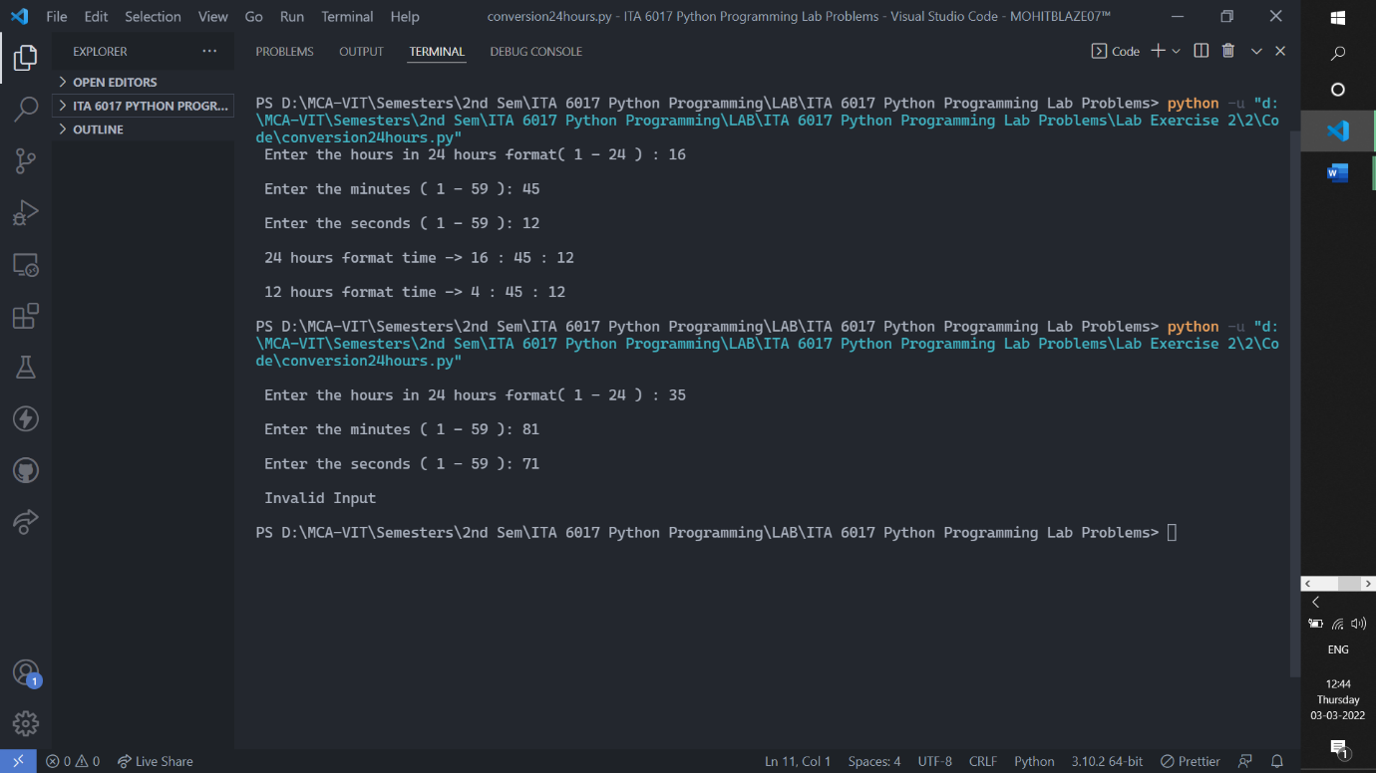



**CODE:**

print("\n Enter the marks out of 100 in 5 different

subjects!\n")

subject1 = int( input("\n Enter the marks of 1st subject: "))

subject2 = int( input("\n Enter the marks of 2nd subject: "))

subject3 = int( input("\n Enter the marks of 3rd subject: "))

subject4 = int( input("\n Enter the marks of 4th subject: "))

subject5 = int( input("\n Enter the marks of 5th subject: "))

totalMarks = 500

sumOfFiveSubjects = subject1 + subject2 + subject3 + subject4 + subject5

percentage = int((sumOfFiveSubjects/totalMarks) * 100)

print( "\nTotal Secured marks: ", sumOfFiveSubjects, "/", totalMarks )

print( "\nYour Percentage: ", percentage,"%" )

if percentage <= 0 or percentage > 100:

    print("\ninvalid input!")

elif percentage >= 90:

    grade = "S"

    print("\nYou have secured ", grade, "grade.")

elif percentage < 90 and percentage >= 80:

    grade = "A"

    print("\nYou have secured ", grade, "grade.")

elif percentage < 80 and percentage >= 70:

    grade = "B"

    print("\nYou have secured ", grade, "grade.")

elif percentage < 70 and percentage >= 60:

    grade = "C"

    print("\nYou have secured ", grade, "grade.")

elif percentage < 60 and percentage >= 50:

    grade = "D"

    print("\nYou have secured ", grade, "grade.")

elif percentage < 50 and percentage >= 40:

    grade = "E"

    print("\nYou have secured ", grade, "grade.")

elif percentage < 40:

    grade = "N or F"

    print("\nYou have secured ", grade, "grade.")

**SCREENSHOT OF OUTPUT:**

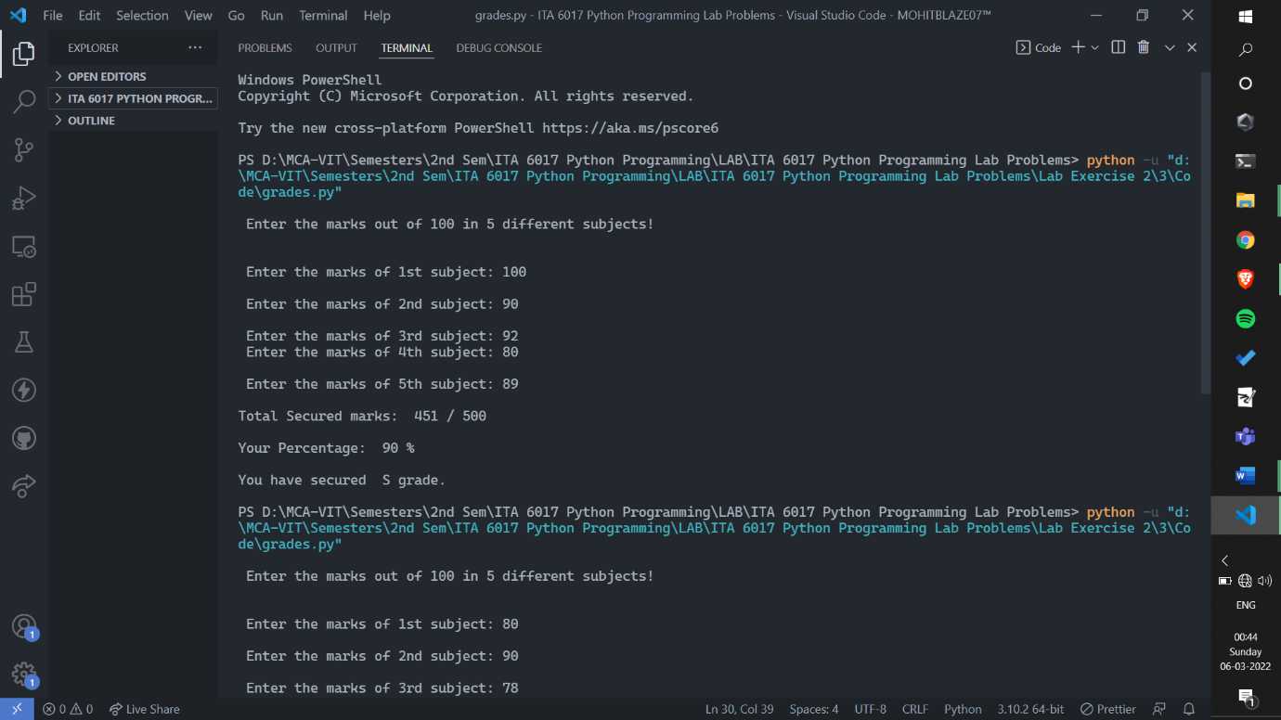

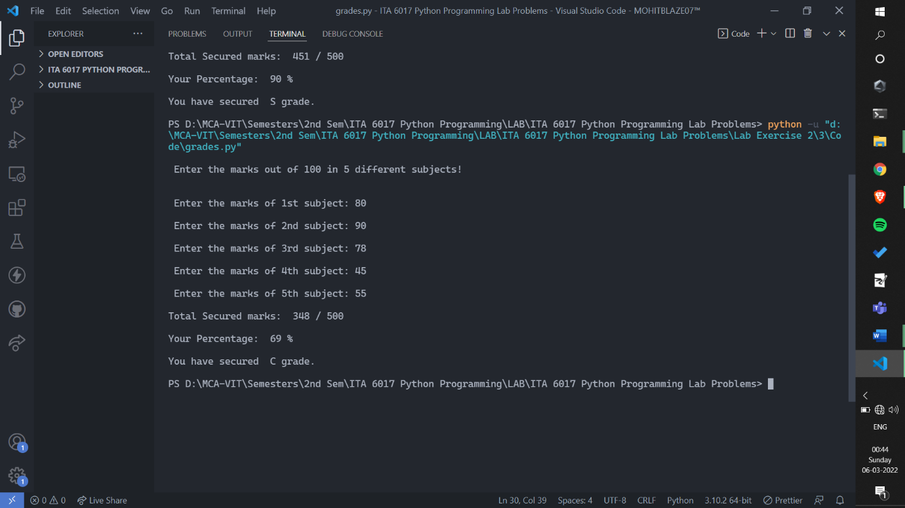

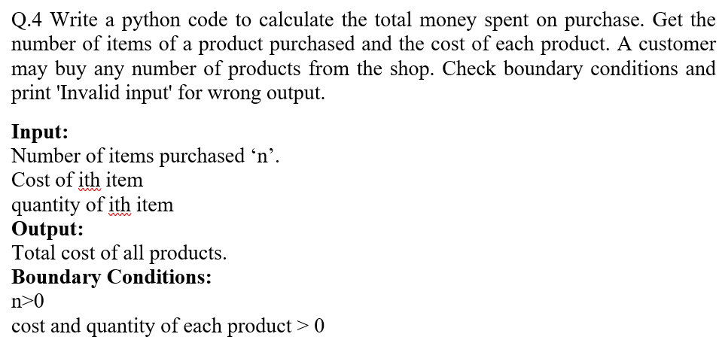

**CODE:**

finalBillAmount = 0

numberOfItemsPurchased = int( input( "\n Enter the number of items purchased: " ) )

if numberOfItemsPurchased <= 0:

    print("\n Invalid Input!\n")

else:

    for i in range( 1, numberOfItemsPurchased + 1 ):

        print("\n Enter details for Item",i,": \n" )

        costOfItem = int( input( "\n\t Enter the cost: " ) )

        quantityOfItem = int( input( "\n\t Enter the quantity: " ) )

        print()

        totalPriceForItem = costOfItem * quantityOfItem

        finalBillAmount += totalPriceForItem

    print("\n The Final Amount to be paid at Bill desk is: Rs", finalBillAmount,"\n")

**SCREENSHOT OF OUTPUT:**

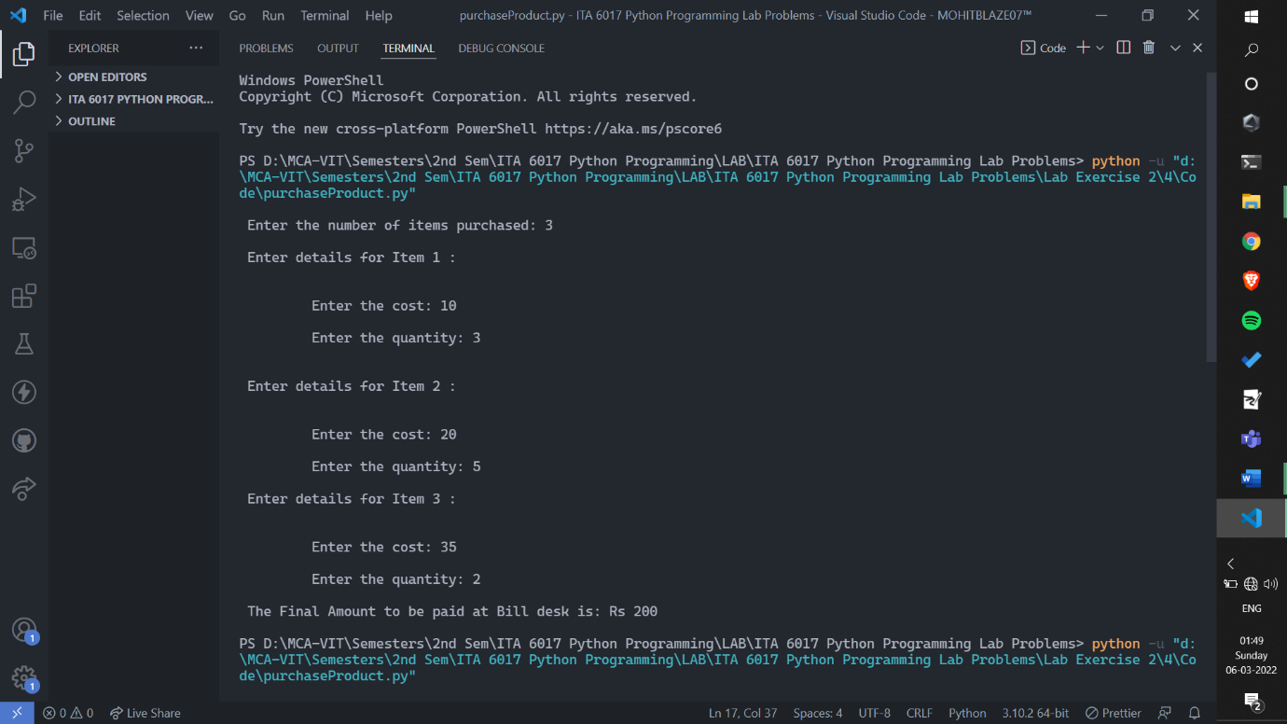

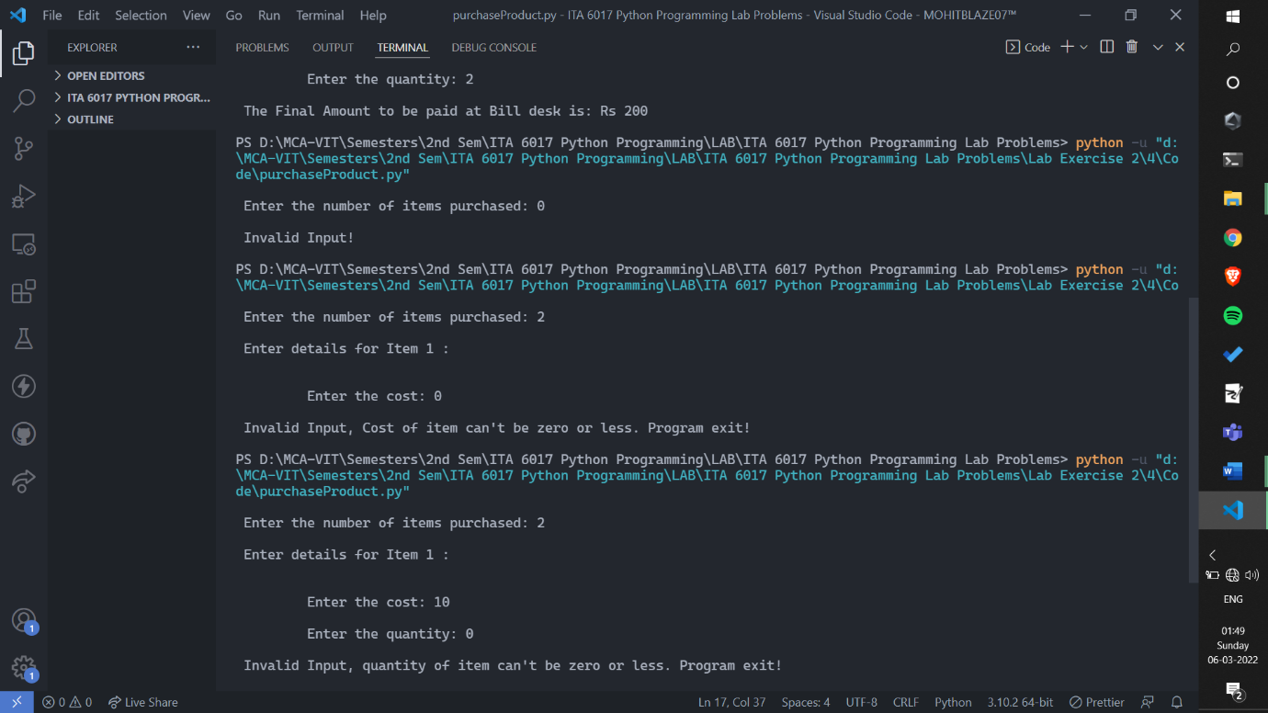

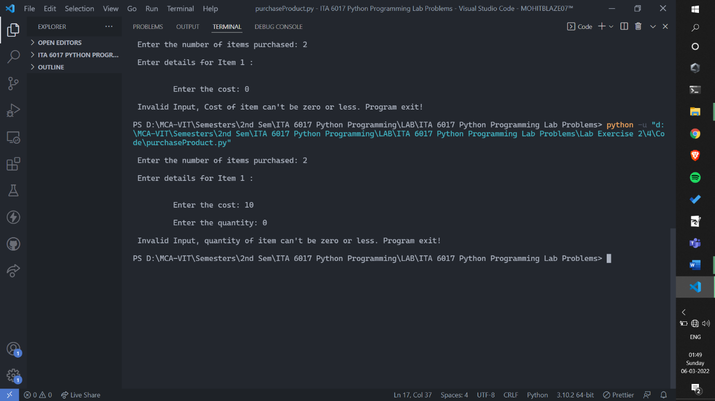

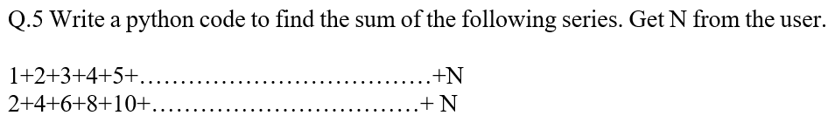

**1.**

**CODE:**

sum = 0

counter = int( input( "\n Enter the N value: " ) )

for i in range( 1, counter + 1 ):

    sum += i

print("\n The sum of first",counter, "natural numbers is:",sum,"\n")

**SCREENSHOT OF OUTPUT:**

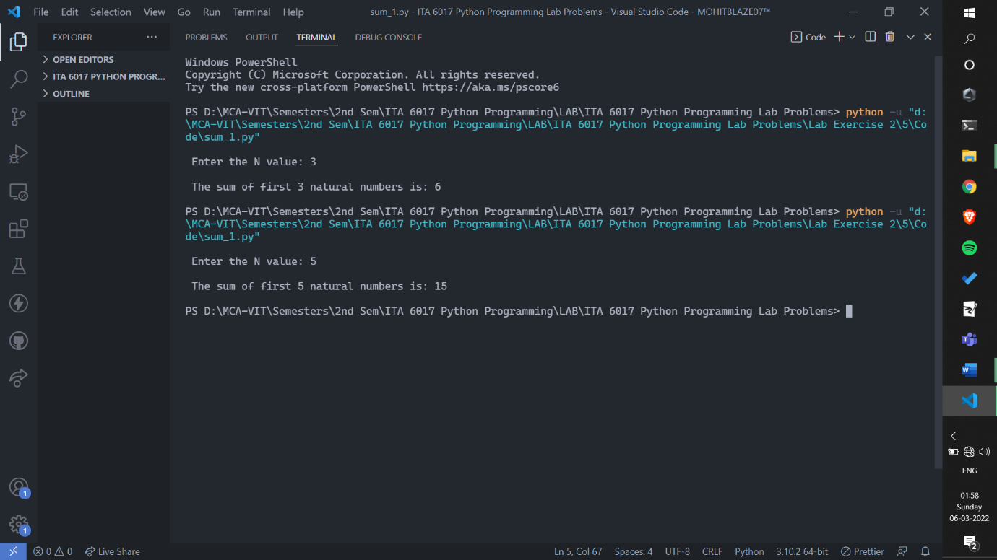

**2.**

**CODE:**

counter = int( input( "\n Enter the N value: " ) )

sum = 0

initialVal = 2

for i in range( 1, counter + 1):

    sum += initialVal

    initialVal += 2

print("\n The sum of first",counter, "even natural numbers is:",sum,"\n")

**SCREENSHOT OF OUTPUT:**

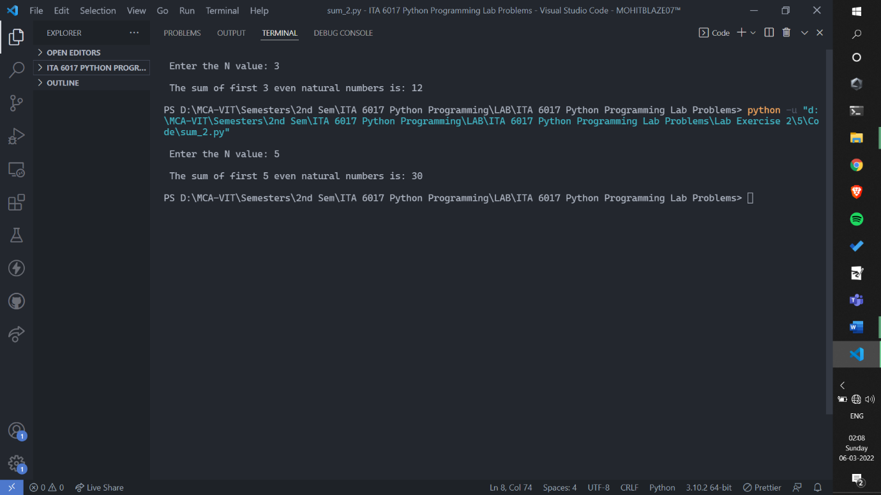

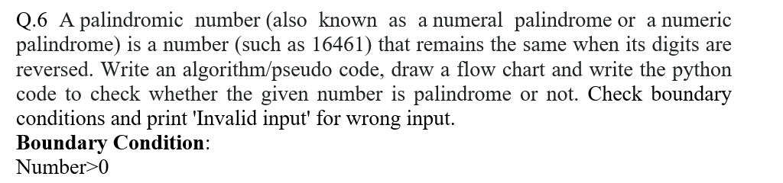

**CODE:**

number = int( input( "\n Enter the number: " ) )

dummyNumber = number

reversedNumber = 0

while number > 0:

    lastDigit = int(number%10)

    reversedNumber = reversedNumber * 10 + lastDigit

    number = int(number/10)

if reversedNumber == dummyNumber:

    print("\n The number",dummyNumber ,"is a Palindromic Number.\n")

else:

    print("\n The number",dummyNumber ,"is not a Palindromic Number.\n")

**SCREENSHOT OF OUTPUT:**

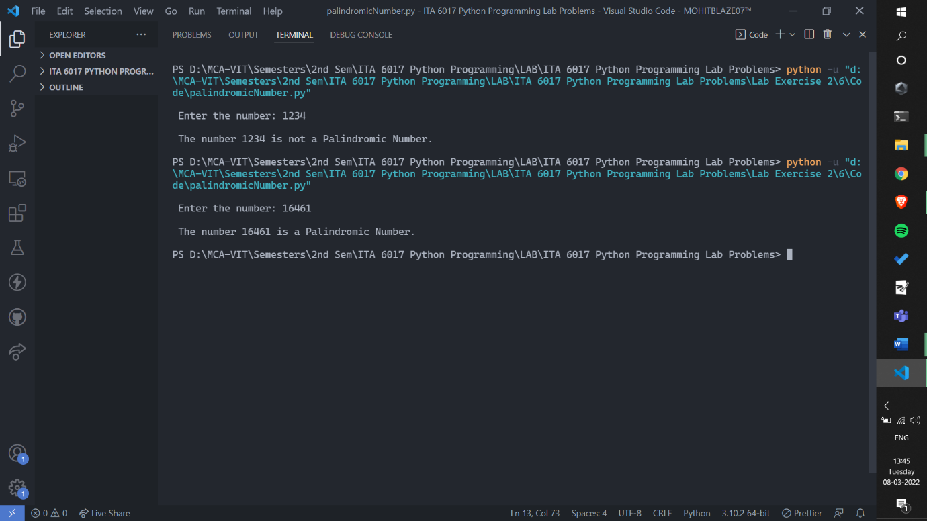

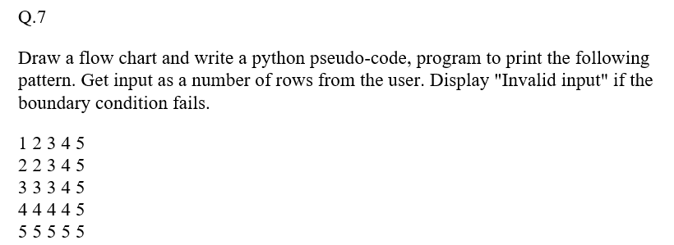

**CODE:**

rows = int(input("\n Enter the number of rows: " )

)

if rows <= 0:

    print("\nInvalid Input!\n")

else:

    print()

    for i in range(1, rows+1):

        for j in range(1, rows+1):

            if j <= i:

                print(i, end=" ")

            else:

                print(j, end = " ")

        print()

    print()

**SCREENSHOT OF OUTPUT:**

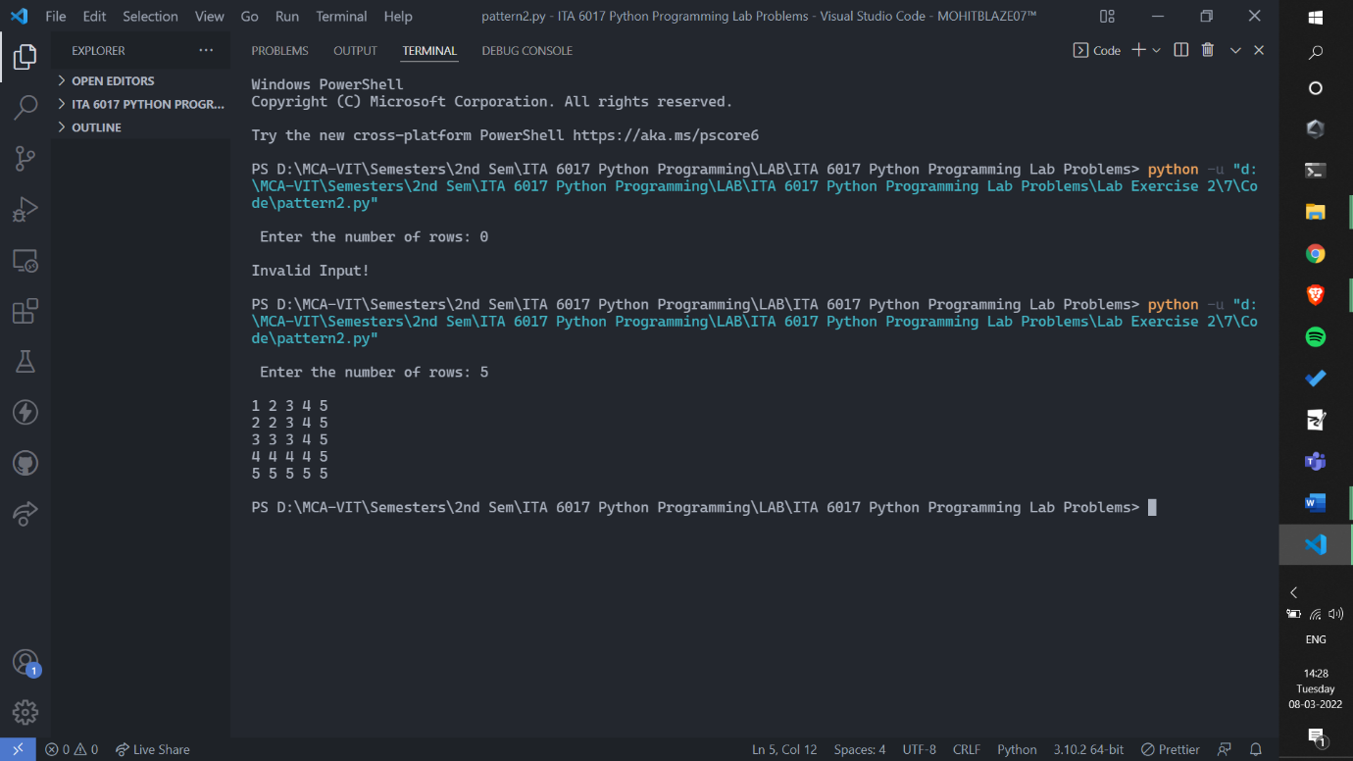

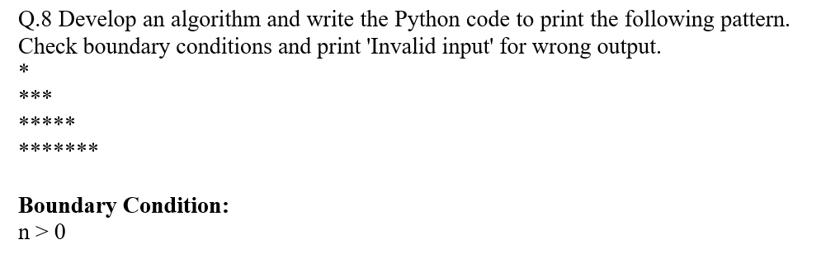

**CODE:**

rows = int( input("\n Enter number of rows: "))

if rows <= 0:

    print("\n Invalid Input!\n")

else:

    count = 1

    for i in range( 1, rows + 1 ):

        for j in range( 1, count+1):

            print("*",end=" ")

        count += 2

        print()

print()

**SCREENSHOT OF OUTPUT:**

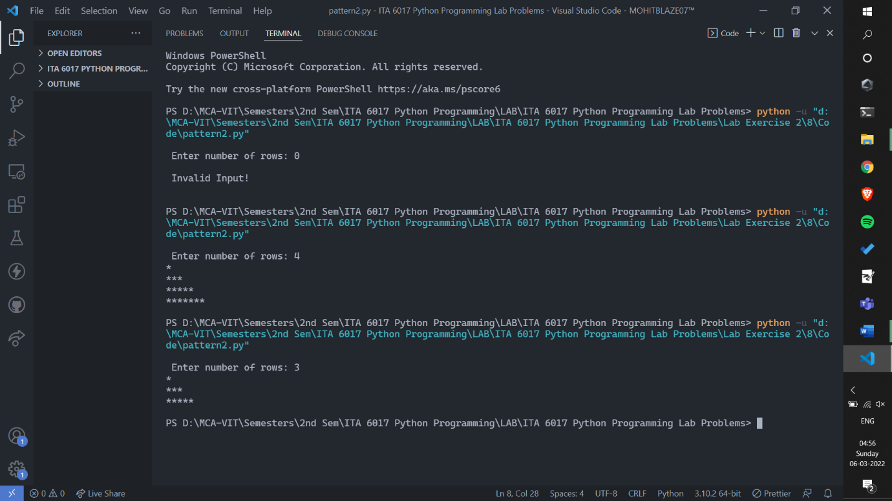



**CODE:**

number = int( input( "\n Enter the number: " ) )

factorialResult = 1

for count in range( number, 0, -1 ):

    factorialResult *= count

print("\n The factorial of",number,"is",factorialResult,"\n")

**SCREENSHOT OF OUTPUT:**

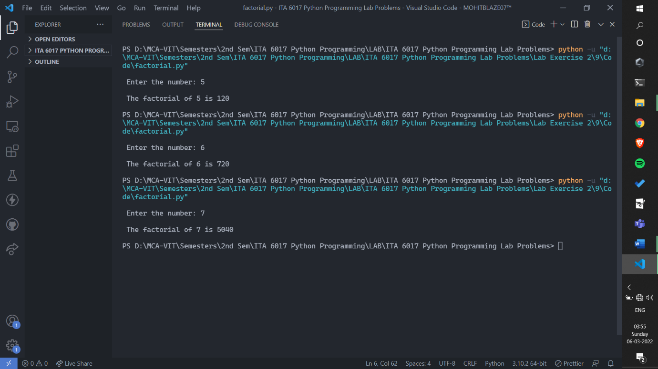



**CODE:**

number = int( input( "\n Enter the number: " ) )

print()

if number < 0:

    print(" Invalid Input!\n")

elif number % 2 == 0:

    print(" The number", number, "is even.\n")

else:

    print(" The number ", number, "is odd.\n")

**SCREENSHOT OF OUTPUT:**

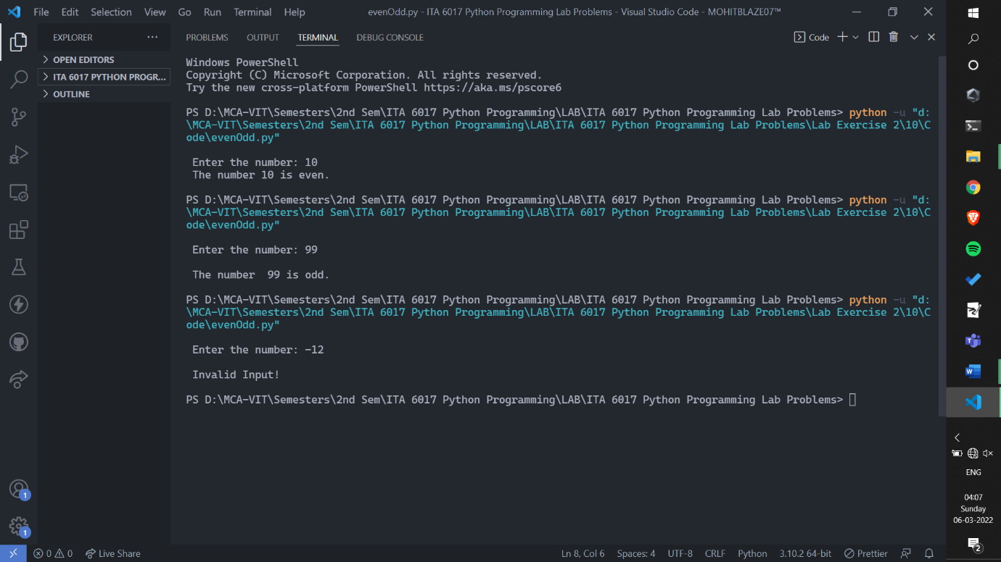



**CODE:**

cgpa = int( input( "\n Enter the CGPA: " ) )

if cgpa < 0 or cgpa > 10:

    print("\n Invalid Input!\n")

elif cgpa <= 10 and cgpa >= 9:

    print("\n Outstanding\n")

elif cgpa < 9 and cgpa >= 8:

    print("\n Excellent\n")

elif cgpa < 8 and cgpa >= 7:

    print("\n Good\n")

elif cgpa < 7 and cgpa >= 6:

    print("\n Average\n")

elif cgpa < 6 and cgpa >= 5:

    print("\n Better\n")

elif cgpa < 5:

    print("\nPoor\n")

**SCREENSHOT OF OUTPUT:**

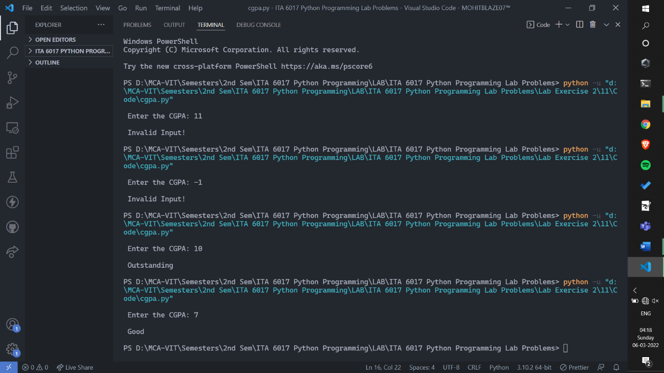

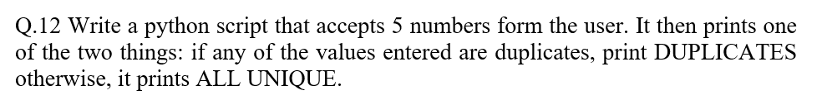

**CODE:**

a = int( input("\n Enter the first value: ") )

b = int( input("\n Enter the second value: ") )

c = int( input("\n Enter the third value: ") )

d = int( input("\n Enter the fourth value: ") )

e = int( input("\n Enter the fifth value: ") )

if a == b or a == c or a == d or a == e or b == c or b == d or b == e or c == d or c == e or d == e:

    print("\n DUPLICATES\n")

else:

    print("\n ALL UNIQUE \n")

**SCREENSHOT OF OUTPUT:**

